In a folder right click and click open git bash here.

Cd folder/ can get me to the folder

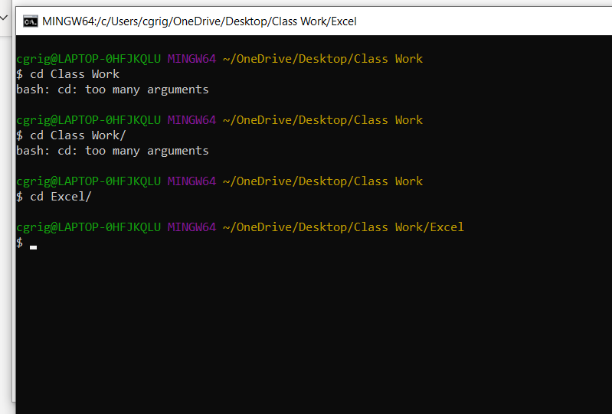

Three things needed to upload changes to Git from the Git bash command.

1. git add . this will add the changes
2. Git comit ~m “put some notes about your change here. This is important”
3. Git push to send all from device to the git site.

